# CS5523 Operating System

# Assignment 4

**Class Diagram:**

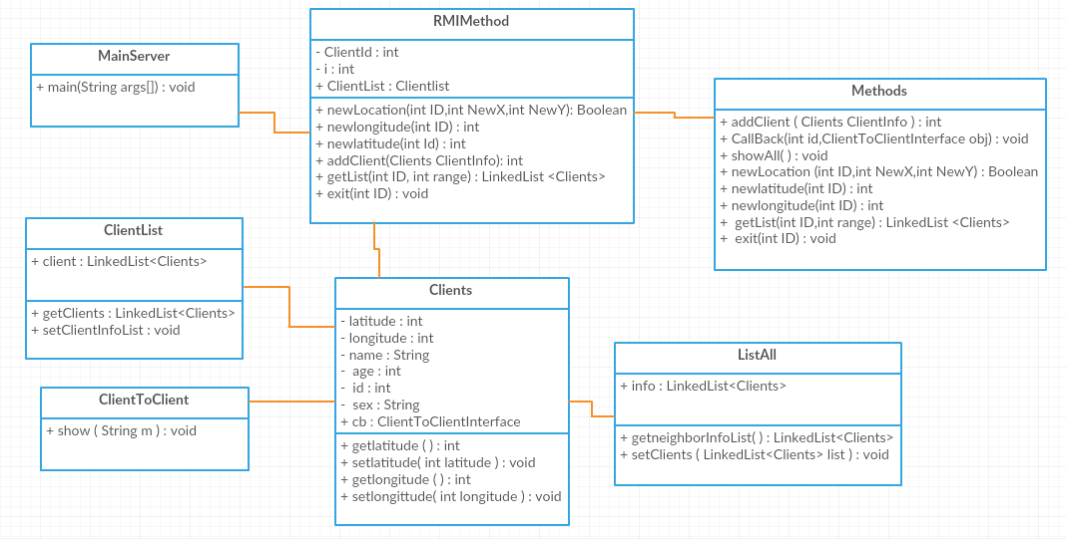

**How to Run:**

1. Execute rmiregistry 1099 &
2. Execute MainServer.java
3. Open multiple command prompts and execute Client.java

**Output:**





